ARCHITECTURE

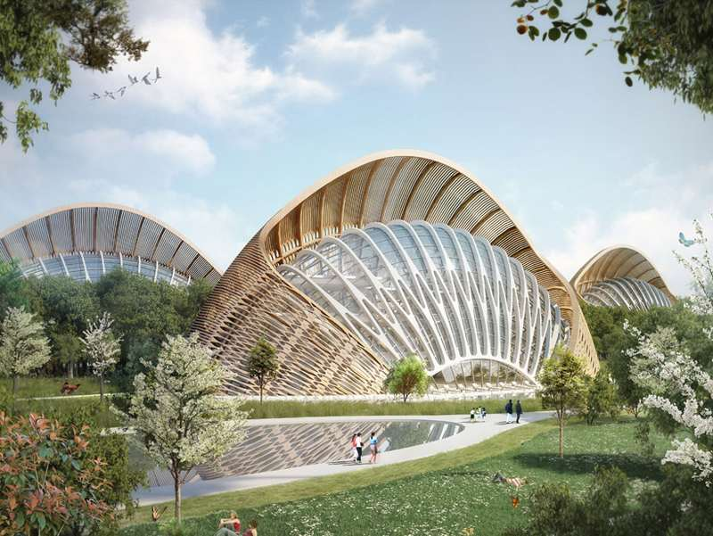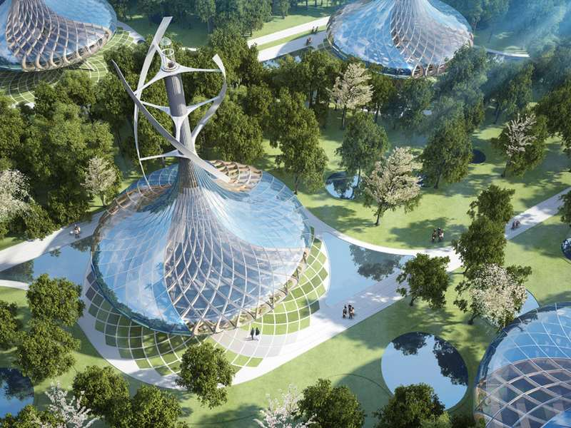

Although I’m not too fond of architecture as a whole, I do find these two buildings very interesting in the sense that they were built to produce more energy than they are to consume. These Eco-friendly Villas are located in Kunming, Southwest China, designed by Vincent Callebaut Architecture. I picked these two buildings mainly because of their unique shape/style that to me; represent the future of architectural design. These mesmerizing buildings honor Dieter Ram’s criteria of good design because of its eco-friendly tendencies as well as being extremely innovative with an infinite number of uses these buildings have to offer.

*(Vincent Callebaut Architecture/ Kunming, China/ “Flavours Orchard”/ May 2014)*

INTERIORS

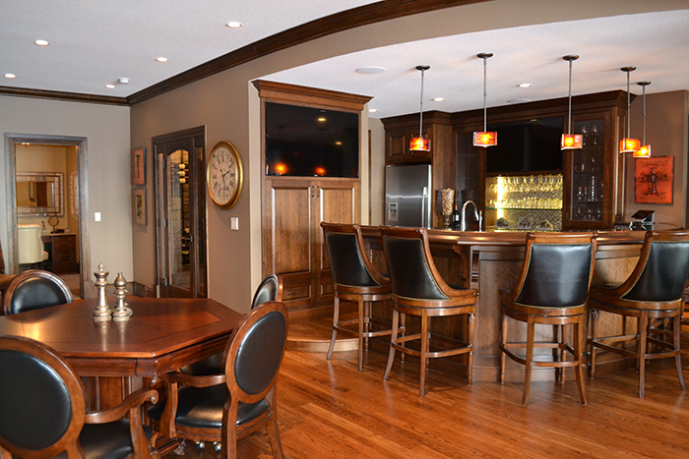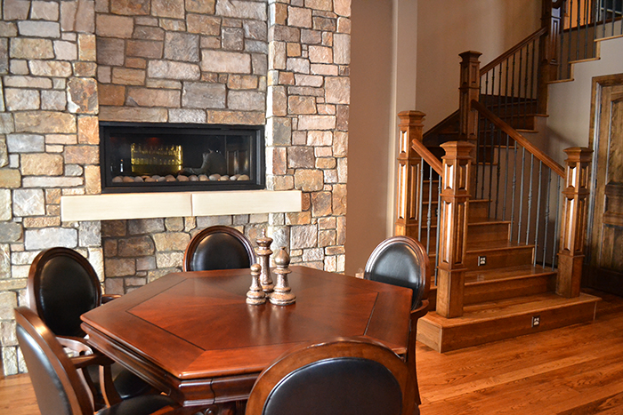

When I think of Interiors I think of designs that are simple yet timeless. I chose these two examples of Bowood Homes Interior because of my love for the look of an elegant wood and stone combo throughout a household. I feel as if wood interiors will never go out of style and will constantly be recognized as one of the most beautiful interior design materials to have in one’s home. As well as being absolutely gorgeous, wooden floors and stone décor are long lasting with only a few touch ups required through out the physical lifespan of a well constructed home.

*(Bowood Design & Build/ Alberta, Canada)*

COSTUME/FASHION/DRESS

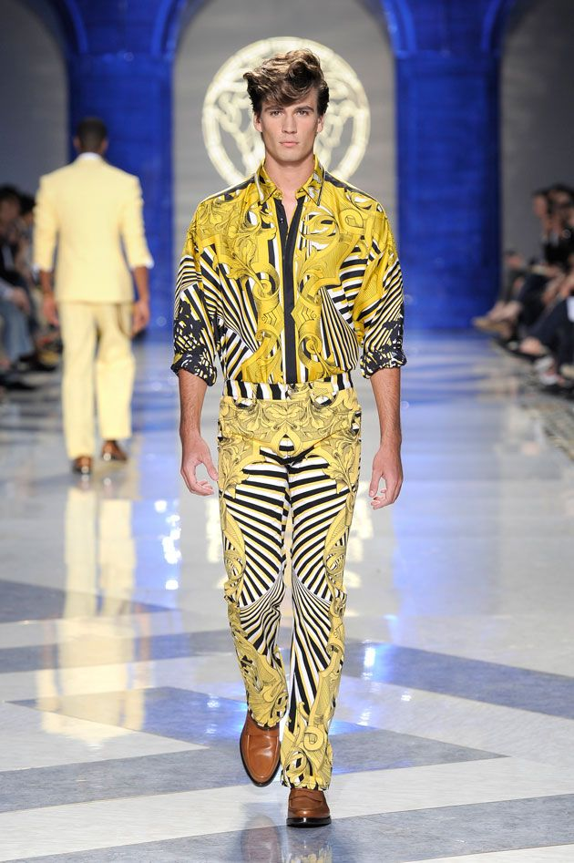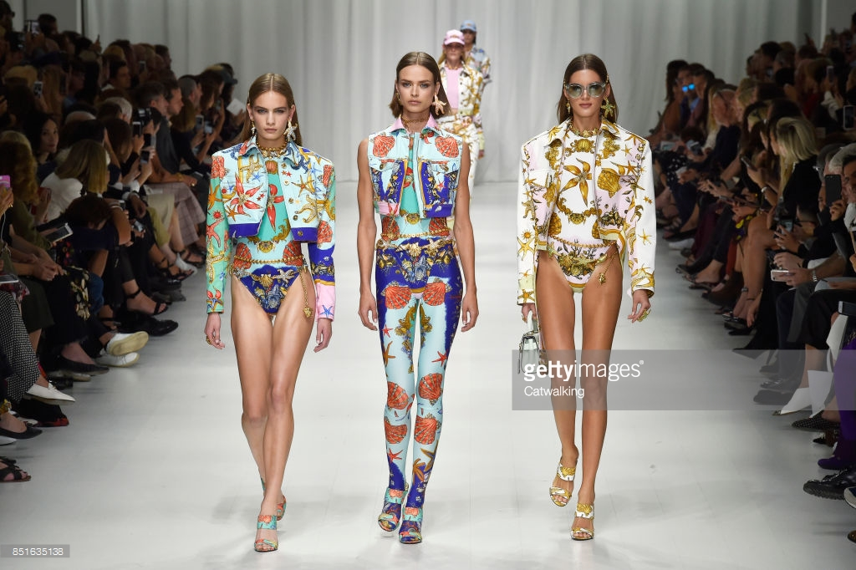

The fashion aspect of design has always been my favorite type of design due to the infinite amount of messages that can come from a designer’s clothing line. My absolute favorite line is the classic Versace clothing line for men & women because I feel as if Gianni & Donatella Versace portray the meaning of life and happiness through their vibrant clothing. Versace has and will always offer beautiful timeless clothing portraying the ideology that life is too short to wear dull clothing so why not make a statement with Versace?

*(Versace/ Milan, Italy)*

GRAPHIC DESIGN

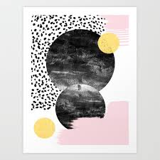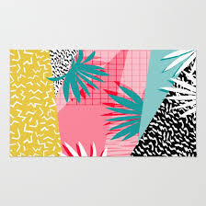

To me, graphic design is similar to fashion in the sense that there can be underlying messages that hide behind these canvases. The beautiful part of graphic design is

that it can be interpreted in 1,000 different ways depending on the type of mood someone’s in that particular day. These objects “wow’d” me in a way that is similar to how Versace’s clothing line continues to fascinate me; they both remind me of happiness and represent my own meaning of living life to the fullest. I felt that these graphic designs are very honest to the human eye of what they are intended to portray as well as being extremely aesthetic.

*(Society 6/ Home Décor)*

PRODUCT DESIGN

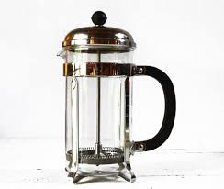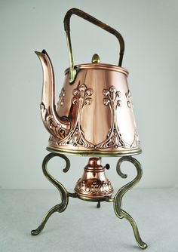

I chose these two kitchen products for a variety of different reasons but partly because I love coffee and tea. These two items are similar to the wooden & stone interior in the sense that they are extremely timeless and long lasting with care. Their simplicity is what makes them useful but their structure is what makes them absolutely beautiful antiques. I personally have my own French press & copper kettle and can proudly say I don’t need any other advanced coffee/tea making tools in my kitchen.

*(RueDesLouves/ Art Nouveau Copper)*